

Practices for Secure Software Report

Table of Contents
Document Revision History 3
Client 3
Instructions 3
Developer 4
1. Algorithm Cipher 4
2. Certificate Generation 4
3. Deploy Cipher 4
4. Secure Communications 4
5. Secondary Testing 4
6. Functional Testing 4
7. Summary 4
8. Industry Standard Best Practices 4

Document Revision History

Version | Date | Author | Comments
1.0 | 04/19/2026 | Raymond Brown | Final Project

Client



Developer
Raymond Brown

Algorithm Cipher
For this project, I implemented secure communication by using HTTPS, which relies on encryption algorithms to protect data in transit. The cipher used is based on TLS (Transport Layer Security), which ensures that any data sent between the client and server is encrypted and cannot be easily intercepted. This is important because without encryption, sensitive data like login credentials or personal information could be exposed. Using TLS ensures confidentiality, integrity, and authenticity of the data being transmitted.

Certificate Generation
To enable HTTPS, I generated a self-signed certificate using Java Keytool. This certificate allows the server to establish a secure connection with the client.
The certificate includes:
- Public key
- Owner information
- Validity period
This certificate is used by the server to prove its identity and encrypt communication.
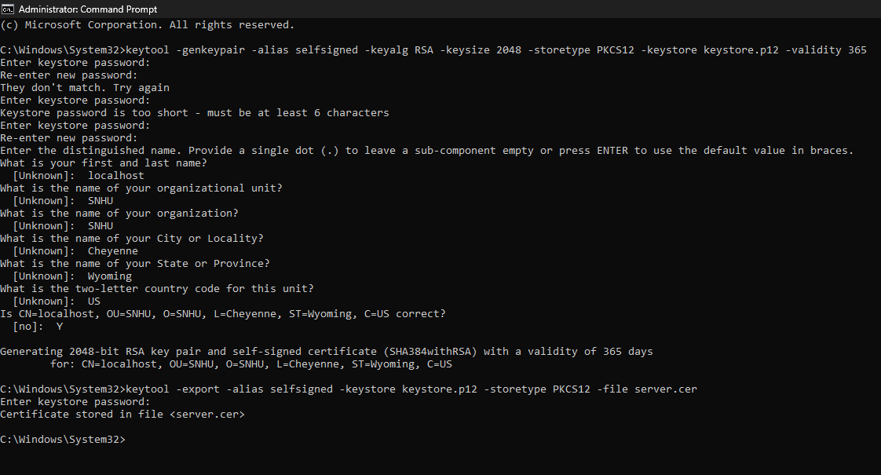
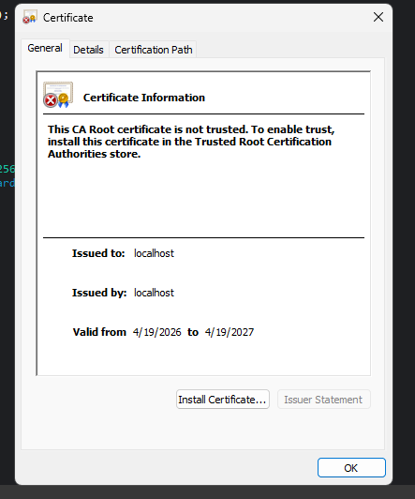

Deploy Cipher
After generating the certificate, I configured the application to use HTTPS by updating the server settings. This included assigning the keystore file and enabling secure port communication. I also verified the integrity of the certificate using checksum validation to ensure it was not altered.
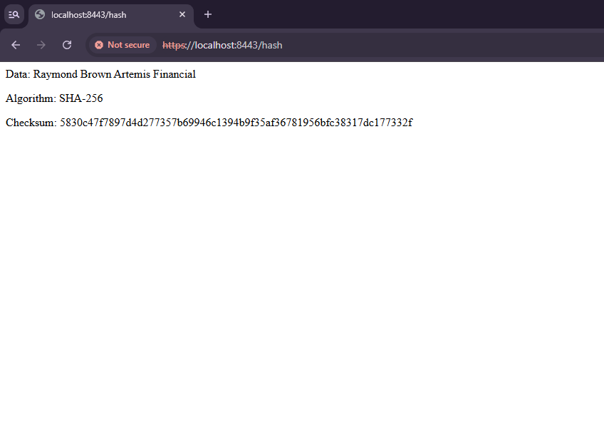

Secure Communications
Once HTTPS was configured, I tested the application in a web browser. The browser displayed a secure connection (lock icon), confirming that the communication between client and server is encrypted. This ensures that all data transmitted is protected from interception or tampering.
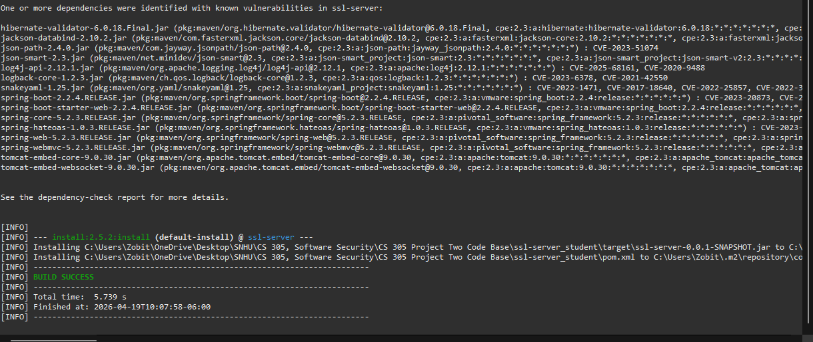

Secondary Testing
After securing the application, I ran OWASP Dependency-Check to identify vulnerabilities in the project dependencies.

The scan found multiple vulnerabilities in outdated libraries, including:
- jackson-databind
- log4j
- logback
- snakeyaml
- spring-boot components
- tomcat-embed

These vulnerabilities could lead to serious issues such as remote code execution, denial of service, or data exposure. I then reviewed the dependency-check report and confirmed that the application builds successfully after analysis.

Functional Testing
After making security improvements, I ran the application to ensure everything still worked correctly. The program executed without errors, confirming that the secure configurations did not break functionality. This step is important because security changes should not impact the usability of the application.

Summary
Overall, this project showed how important it is to secure applications both in communication and in dependencies. By implementing HTTPS and generating a certificate, I ensured secure data transmission. Additionally, using OWASP Dependency-Check helped identify vulnerabilities that could be exploited if left unpatched. This project reinforced the importance of keeping dependencies updated and regularly testing for security issues.

Industry Standard Best Practices
Some industry standard best practices demonstrated in this project include:
- Using HTTPS for all communications
- Encrypting sensitive data in transit
- Regularly scanning for vulnerabilities using tools like OWASP Dependency-Check
- Keeping dependencies updated to avoid known exploits
- Validating inputs to prevent injection attacks
- Following secure coding practices throughout development

- Dependency Check:

